Project

**Record Payment: SAPI**

# Business Scenario

This API will record Payment Details in the Payment Table.

# API Landscape

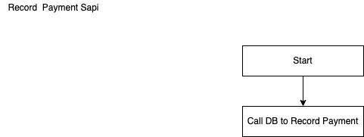

Sequence Diagram Web Application

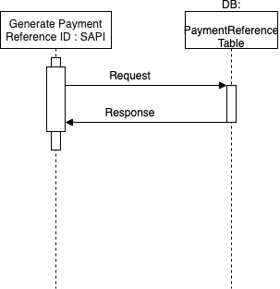

API Details:

|  |  |
| --- | --- |
| **Version** | 1.0.0 |
| **Resource** | payments |
| **Method** | POST |
| **Objective** | This API will record Payment Details in Payment Database. |

INPUT

Header

|  |  |  |  |
| --- | --- | --- | --- |
| **Field Name** | **Field Rule** | **Mandatory** | **Type** |
| x-abc-transactionId | Use for logging and tracking purposes. Example: hdsfhjdh-jxbv859-sjdf7643-3746bbd  MinLenght = 36  MaxLength = 36 | Y | String |

Body

MIME-Type = application/json

|  |  |  |  |
| --- | --- | --- | --- |
| **Field Name** | **Field Rule** | **Mandatory** | **Type** |
| recordPaymentTransaction |  | Y | Object |
| transactionReferenceId | “TDGDBw387483” | Y | String |
| responseCode | “100” | Y | String |
| amount | 5000 | Y | Number |
| paymentCurrencyCode | “USD” | Y | String |
| dateTimeOfTransaction | “2021-04-01 12:23:34” | Y | String |
| paymentMode | “credit” | Y | String |
| CreditCardNumber | “7465-7646-8734-7634” | N | String |
| debitCardNumber | “7465-7646-8734-7634” | N | String |
| upiNumber | “dsjfghsdgfjsdfjsgfwryti” | N | String |
| NameOfCustomer | “XYZ” | Y | String |
| paymentReferenceId | “jdhsfjhd87645” | Y | String |

Example :

{

"recordPaymentTransaction":

{

"transactionReferenceId" : "TDGDBw387483",

"responseCode": "100",

"amount": 5000,

"paymentCurrencyCode" : "USD",

"dateTimeOfTransaction" : "2021-04-01 12:23:34",

"paymentMode" : "credit",

"CreditCardNumber" : "7465-7646-8734-7634",

"debitCardNumber" : "7465-7646-8734-7634",

"upiNumber" : "dsjfghsdgfjsdfjsgfwryti",

"NameOfCustomer" : "XYZ",

“PaymentReferenceId”: “jdhsfjhd87645”

}

}

OUTPUT

200

Body: MIME-Type= application/json

Output message for RecordPayment

|  |  |  |  |
| --- | --- | --- | --- |
| **Field Name** | **Field Rule** | **Mandatory** | **Type** |
| responseCode |  | Y | Number |
| responseMessage |  | Y | String |

example:

{

"responseCode": 200,

"responseMessage": "Payment Recorded Successfully"

}

400:

Body: MIME-Type= application/json

Output message for RecordPayment

|  |  |  |  |
| --- | --- | --- | --- |
| **Field Name** | **Field Rule** | **Mandatory** | **Type** |
| errorCode |  | Y | Number |
| errorMessage |  | Y | String |

example:

{

"errorCode": 400,

"errorMessage": "BAD Request"

}

401:

Body: MIME-Type= application/json

Output message for RecordPayment

|  |  |  |  |
| --- | --- | --- | --- |
| **Field Name** | **Field Rule** | **Mandatory** | **Type** |
| errorCode |  | Y | Number |
| errorMessage |  | Y | String |

example:

{

"errorCode": 401,

"errorMessage": "UnAuthorised"

}

404:

Body: MIME-Type= application/json

Output message for RecordPayment

|  |  |  |  |
| --- | --- | --- | --- |
| **Field Name** | **Field Rule** | **Mandatory** | **Type** |
| errorCode |  | Y | Number |
| errorMessage |  | Y | String |

{

"errorCode": 404,

"errorMessage": "Not Found"

}

500:

Body: MIME-Type= application/json

Output message for RecordPayment

|  |  |  |  |
| --- | --- | --- | --- |
| **Field Name** | **Field Rule** | **Mandatory** | **Type** |
| errorCode |  | Y | Number |
| errorMessage |  | Y | String |

{

"errorCode": 500,

"errorMessage": "Critical Error"

}